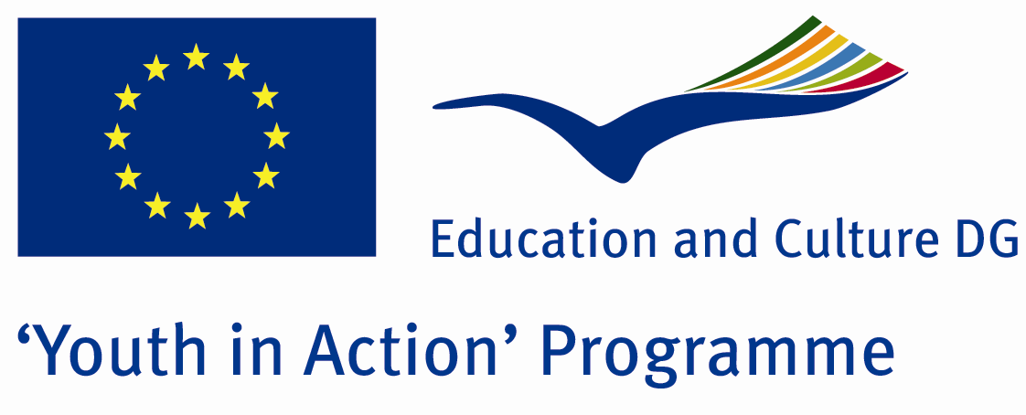

Good Partner Equals Good Project



ACTION 4.3 – TRAINING AND NETWORKING

09-15th January, 2012

Kırklareli , TURKEY

ACTION 4.3 – TRAINING AND NETWORKING
09-15th January, 2012
Kırklareli, TURKEY

Please contact directly to;
adventurerpeacepigeons@gmail.com

Project Summary;

There must be good partnership and a good division of labour to make a successful project.In this context, we want to find good partners for our projects in future and we want to introduce to our future partners closely..So we can know each other,we can strenghten our relationship and we can do beter projects together..The aim of this Project is make good partnership and relationship for future projects.

Project Title; Future Partners

Date and Venue ; 09-15th January, 2012,Kırklareli, Turkey .

Target Group ; Municipalities, City Councils and Non-Governmental organizations,
youth groups,culture and art groups,e.t.c

Participants ; 5 people from each country (over 18 -25 ). Totally 8 countries.

Conditions ; Accommodation, board and programme costs will be financed through European Commission Youth in Action Programme (Action 4.3). Travel costs will be reimbursed in 70% (APEX Tarrifs). Organizations from all 27 EU member countries plus Liechtenstein , Norway and Iceland are eligible to take part.

Working language: English

Organizer; Adventurer Peace Pigeons

How to apply: If you are interested, please send your Part III forms to
by e-mail please (in word file). Scan Part3 format is enough for application.(Fulfilled Part III which you can find in the attachment, of course signed and stamped) ..

Next step 2;
Original send via regular post to this address please:

Ertan DERİN
Fevzi Çakmak Mahallesi Tuncer Sokak No:6 PENDİK/İSTANBUL/TÜRKİYE
e-mail : adventurerpeacepigeons@gmail.com
Mobile : 0090 542 393 93 90

If you have any questions you may contact with: adventurerpeacepigeons@gmail.com

Deadline: 15th May 2011

For Further information:
Contact Person
Ertan DERİN
Fevzi Çakmak Mahallesi Tuncer Sokak No:6 PENDİK/İSTANBUL/TÜRKİYE
e-mail : adventurerpeacepigeons@gmail.com
Mobile : 0090 542 393 93 90

